PERSONAL INFORMATION | Marko Selakovic, MSc (Business)
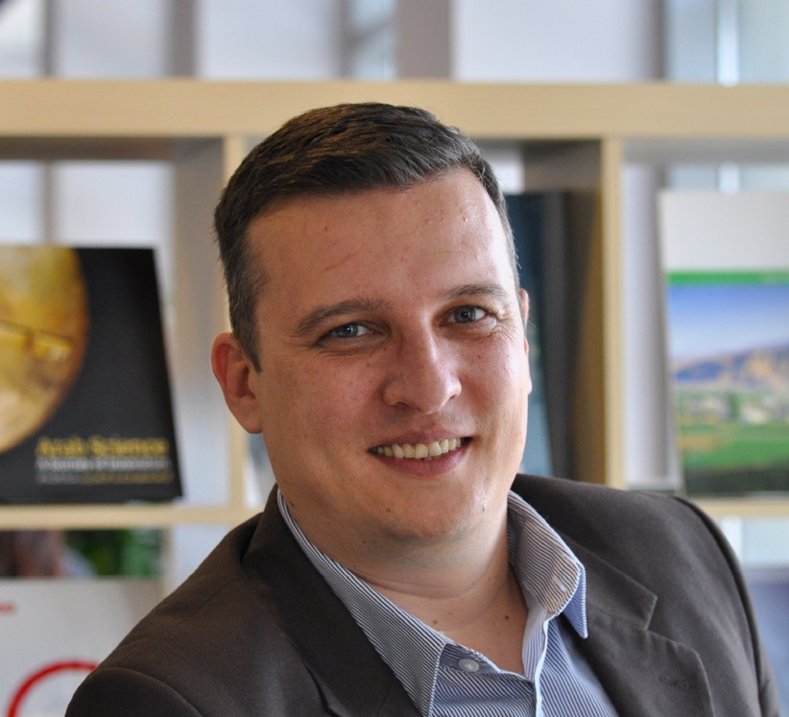 |   Dubai, United Arab Emirates

+97143271654  +971551523633

selakovic345@gmail.com

https://en.wikipedia.org/wiki/Marko_Selakovic; www.researchgate.net/profile/Marko_Selakovic

https://twitter.com/ljutomir
 | Gender Male | Date of birth 16/10/1977 | Nationality Serbian / UAE Resident

INTRODUCTION | UAE-based strategic communications and management professional with 15 years of successful experience in creating strategies and providing advisory to senior and C-suite executives of the international organizations, government entities, education and business sector. Excellent management, presentation, public speaking, teaching, training and leadership skills. Strong professional network in the GCC and European countries. Holder of the numerous awards for strategic communication, crisis communications and public relations campaigns. MSc Business – International Business. Vice-President of the International Association of Business Communicators (IABC) GCC Chapter.

WORK EXPERIENCE

2017-present | Advisor to the Chairman of the Board
2017-present | Al Jazira Sports and Culture Club, Abu Dhabi, UAE
2017-present | - Creation, development and delivery of the stakeholder relations strategies  - Managing international communications and relations  - Communication with top-level and C-suite local and international officials  - Creation, development and delivery of the sponsor/partner relations strategies and initiatives  - Managing relationships with the international authorities, diplomats and foreign clubs and associations  - Leading Committee for implementation of Al Jazira – Red Star Twinning Agreement  - Providing counsel to the Chairman of Al Jazira SC on business processes optimization, strategic planning and development
2017-present | Sports and Culture Club
2016-2017 | Supervisor (Executive Position) – Continuing Education & Training Centre
2016-2017 | American University in the Emirates, Dubai, UAE
2016-2017 | - Strategic planning and strategy execution  - Partner/stakeholder management  - External and internal identification of learning and training needs  - Design and development of learning and training programs  - Presentation of the centre towards the external audiences  - Liaison with business and Government entities  - Developing policies, procedures and documents aligned with domestic regulations and demands of the national and international academic accreditation authorities  - Strategic planning and communication with internal audiences – Board, faculty members  - Supervision of the training programs implementation  - Researching best practices and designing learning programs curricula and solutions  - Training of trainers, faculty members and staff
2016-2017 | Academia
2014-2015 | Advisor to the Director General – Corporate Communications and Public Affairs
2014-2015 | Pharmaceutical Chamber of Serbia, Belgrade, Serbia
2014-2015 | - Consultancy and advisory in organizational development, stakeholder relations and communications  - Creation, development and delivery of communication and stakeholder relations strategies, including communication with Government and national and international authorities and entities  - Providing feedback, training and education to the Director General and top staff for national and international public and media appearances  - Creating and managing Government relations strategies and activities  - Managing strategic communications and public affairs activities
2014-2015 | Professional Chamber
2012-2014 | Guest/Visiting Lecturer – Communications and Campaigning
 | University of Belgrade – Faculty of Political Sciences, Belgrade, Serbia
- Visiting lecturer - communications and campaigning
- Preparing content and learning outcomes
- Individual work with students
- Keynote speaker on Faculty PR Days
 | Academia
2012-2014 | Spokesperson and Chief Information Officer
2012-2014 | United Regions of Serbia, Belgrade, Serbia
2012-2014 | - Creation, development and implementation of strategic communications concept of the United Regions of Serbia, parliamentary political party  - Representing United Regions of Serbia, parliamentary political party, in public  - Managing external and internal communications of the party, managing PR office of the party with 10-12 full-time employees, managing relationships with the agencies  - Crisis communication planning and handling, pivoting crisis communication team  - Communications consultancy and advisory to party leaders and top officials  - Creation and implementation of communication strategies and campaigns on national and local level  - Member of the Presidium, Presidential Collegium and Executive Board responsible for communication  - Pivoting media relations on local, national and international level, leading team of 60 PR managers  - Managing relationships with communication departments of the European-level associations, such as European People`s Party (EPP)
2012-2014 | Political Organization
2012-2014 | Advisor to the Deputy Prime Minister and Minister of Finance and Economy
2012-2014 | Government of Serbia, Belgrade, Serbia
2012-2014 | - Creation, development and implementation of strategic communications concept of Mr. Mladjan Dinkic, Deputy Prime Minister of the Government of Serbia, Minister of Finance and Economy and Deputy Chair of the Serbia-UAE Co-operation Committee  - Supervising operations and work of the Deputy Prime Minister PR office  - Managing crisis communication  - Providing advisory in setting up national and international advocacy and rebranding campaigns
2012-2014 | Government
2010-2012 | Advisor to the Minister of Youth and Sports
2010-2012 | Government of Serbia, Belgrade, Serbia
2010-2012 | - Creation, development and implementation of strategic communications concept of HE Mrs. Snezana Samardzic Markovic, Minister of Youth and Sports in the Government of Serbia  - Pivoting advocacy and public affairs campaigns  - Supervising operations and work of the Ministry PR office  - Handling international communications of the Minister  - Managing crisis communication  - Providing strategic advisory for the key international events, such as European and World Championships organized in Serbia
2010-2012 | Government
2010-2012 | Mentor – Graduate Student Professional Practice
 | University of Belgrade – Faculty of Organizational Sciences, Belgrade, Serbia
- Mentoring and transferring knowledge and good communications practice to students
- Assessing practical skills of students
- Preparing recommendations for curriculum development and modifications
 | Academia
2007-2014 | Consultant for Vocational Education Reform
 | Government of Germany - GIZ and Government of Serbia Ministry of Education, Belgrade, Serbia
- Pivotal role in strategic development of the vocational education reform in Serbia
- Creation and managing of public relations and awareness-raising campaigns within the project of the vocational education and training reform in Serbia
- Providing consultancy in internal communications and organizational development of the structures built within the project of the vocational education reform in Serbia
- Capacity development of headmasters and educational institutions involved into the project regarding communications, partner management and process management
- Pivotal role into formation of the Regional Centres of Competences
- Preparation of the strategic documents and papers related to the program development and organizational development
- Preparing curricula and assessment of proposed learning outcomes with the stakeholders
- Providing consultancy to the institutions responsible for implementation of the reform steps, monitoring policy development and implementation of the innovations – Ministry of Education, Serbian Chamber of Commerce, National Employment Service, Government of Serbia - Vocational Education and Training Centre
- Preparing project leaders for meetings with ministers and key decision-makers
- Member of the appraisal missions for project re-shaping and extension
 | Education
2007-2012 | Managing Director
2007-2012 | StratCom, Belgrade, Serbia
2007-2012 | - Pivoting business operations of StratCom, one of leading Serbian strategic communication agencies  - Leading agency team of 8-10 employees  - Managing relations with key national and international clients  - Creation and implementation of the campaigns for the key clients of the agency  - Decision-making and strategic development
2007-2012 | Strategic Communications
2006-2007 | Senior Consultant – Account Director
2006-2007 | Logos Public Relations, Belgrade, Serbia
2006-2007 | - Managing key clients such as Japan Tobacco International, Giunti, Ministry of International Economic Relations  - Managing team of 4 people
2006-2007 | Strategic Communications
2004-2006 | Consultant – Account Manager
2004-2006 | Hauska & Partner International Communications, Wien, Austria
2004-2006 | - Managing key clients such as Sony Ericsson, Economist Media Group, Philips
2004-2006 | Strategic Communications
2001-2004 | Project Manager and Consultant
2001-2004 | Centre for Training, Analyses and Resources, Belgrade, Serbia  - Creating and managing projects “Rule of Law in Media” and “Balkan-Caucasus NGO Network”
2001-2004 | Expert Organization

EDUCATION AND TRAINING

2016-2017 | Master of Science in Business | QFEmirates  Level 9
2016-2017 | DOBA Faculty of Applied Business and Social Sciences, Maribor, Slovenia
2016-2017 | - Graduated with great distinction – Summa Cum Laude  - GPA 10 out of 10  - International Business  - Knowledge Management  - Stakeholder Communications and Lobbying  - Organizational Dynamics  - Innovation Management

2005-2009 | Bachelor of Science with Honours – Natural Sciences | QFEmirates  Level 7
2005-2009 | University of Pristina, Kosovska Mitrovica, Serbia
2005-2009 | - Graduated with great distinction  - GPA 9,09 out of 10  - Chemistry  - Philosophy of Natural Sciences  - Teaching Methods

1998-2002 | Alumni – Council of Europe Leadership Program
1998-2002 | Council of Europe – Directorate General of Political Affairs, Strasbourg, France
1998-2002 | - Leadership  - Communications  - Critical Thinking  - Media Relations  - Project Management  - Policy Making

PERSONAL SKILLS

Mother tongue(s) | Serbian, English
Other language(s) | UNDERSTANDING |  | SPEAKING |  | WRITING
Other language(s) | Listening | Reading | Spoken interaction | Spoken production
German | C1 | C1 | B2 | B2 | B2
Russian | B1 | B1 | B1 | A2 | A2
Arabic | B1 | A2 | B1 | A2 | A2
 | Levels: A1/A2: Basic user - B1/B2: Independent user - C1/C2 Proficient user

Communication skills | - proficient communication skills gained through the experience as a spokesperson and PR manager  - proficient public speaking skills gained through the experience as a spokesperson and PR manager  - proficient teaching/training skills gained through the experience in education and training  - proficient crisis communications and crisis management skills gained through the career experience  - excellent interpersonal communication skills gained through the experience as an advisor  - excellent active listening skills gained through more than 15 years of professional experience  - excellent internal communication skills gained through the experience as director and advisor  - excellent digital communication skills gained through the experience of digital campaigning  - good diplomatic communication skills gained through the experience as an advisor

Organisational / managerial skills | - leadership – more than 10 years of experience in senior and leadership roles  - decision-making – more than 10 years of experience in senior and leadership roles  - team management – gained through more than 10 years of the team leading experience  - strategic thinking and planning – pivotal role in setting more than 50 strategic projects  - implementing strategies – gained through implementation of more than 40 strategies  - goal setting and goal meeting – gained through more than 10 years of senior experience  - project management –more than 10 years of experience  - conflict resolution – gained through mediation of numerous crisis situations and conflicts  - multitasking – gained through more than 10 years of experience in managing multiple tasks

Job-related skills | - strong command of the academic research methodologies  - strong command of the academic writing  - strong command of designing curricula and learning outcomes  - good command of policies and procedures creation  - excellent knowledge of group dynamics  - excellent knowledge of learning and development methodologies and techniques  - excellent training and coaching skills

Digital competence | SELF-ASSESSMENT
Digital competence | Information processing | Communication | Content creation | Safety | Problem solving
 | Proficient user | Proficient user | Proficient user | Independent user | Independent user
 | Levels: Basic user - Independent user - Proficient user
- strong command of office suite (word processing, spread sheet, presentation software)
- strong command of collaborative platform programs and tools (SharePoint, Akademia, Blackboard)
- good command of photo editing and design software
- good command of the survey design and analysis software and platforms

Other skills | - adaptability and flexibility – worked in different conditions and countries  - ability to manage the international teams – gained through the working experience  - ability to work in multinational and multicultural teams – gained through the working experience  - entrepreneurial skills – developed through leading operations of the small enterprise  - writing skills – experienced writer and blogger  - networking skills – strong socializer and networker

Driving licence  Social activities | UAE Driving license – Light Motor Vehicles  International driving license  Serbia Driving License – B category  Registered volunteer - UAE  Active sports (handball)  Music (playing drums)

Publications  Presentations  Honours and awards  Memberships  Courses  Certifications | Selakovic, M. & Skoko, B. (2017). Economic and Reputation Implications of the Online Paracrises in the Emerging Markets. Accepted by AUEIRC2017 / Springer  Selakovic, M. (2017). Strategic Communication and Service Sector Innovation: The Case Study of a Restaurant in Smart City Environment. Accepted by AUEIRC2017 / Springer  Selakovic, M. & Ljepava, N. (2017). Managing innovation changes in the contemporary environment. Accepted by Vojno Delo  Runic Ristic M., Selakovic M. & Qureshi, T.M. (2017). Employee motivation strategies and creation of supportive work environment in societies of post-socialist transformation. Polish journal of management studies, 15(2), 205-217  Malouf, A.,Selaković, M. & Ljepava, N. (2016). Exploring the relationship between corporate volunteering and internal communications in multinational organizations. Communications management review, 1(2), 6-22  Ljepava, N. & Selakovic, M. (2014). Entrepreneurship and market trends in public relations and market research industries in Serbia, REDETE conference, Banja Luka  Ljepava, N. & Selakovic, M. (2014). Interpersonal relationships as determinants of faculty job satisfaction. SYMORG. University of Belgrade Faculty of Organizational Sciences  Ljepava, N. & Selakovic, M. (2010). Non-governmental organizations and online social networking: Serbian Parents Network case study. SYMORG. University of Belgrade Faculty of Organizational Sciences  Selakovic, M., Karanac, R. & Papic, M. Ž. (2009). Strategic planning of development of the expert organizations: case study of schools in Moravica district. Conference proceedings, Split: Faculty of Management Novi Sad  Selakovic, M. & Papic, M. Ž. (2009). Shaping educational offer of the vocational schools through implementation of knowledge management concept. Conference proceedings, Split: Faculty of Management Novi Sad  Selakovic, M. & Karanac, R. (2009). Preservation and development of organizational knowledge in management of the vocational schools in the Republic of Serbia. TIO conference proceedings, University of Novi Sad Faculty of Technical Sciences  Selakovic, M. & Papic, M. Ž. (2009). Role and application of the ICT in establishment of the contemporary school management. TIO conference proceedings, University of Novi Sad Faculty of Technical Sciences  Panellist – Citizen for Media – BlogOpen (2014) - Serbia  Keynote Speaker – PR Days (2013, 2012) - Serbia  Panellist – TVET Conference (2013) - Serbia  Keynote Speaker – Blogomanija Conference (2012) - Serbia  Panellist – Branding Conference (2012) - Serbia  Keynote Speaker – Branding Ignite (2012, 2011, 2010) – Serbia  Keynote Speaker – National PR Conference (2010) – Bosnia and Herzegovina  Keynote Speaker – Safety of Children (2009) - Serbia  Keynote Speaker – BrandStorming Conference (2009) - Serbia  Keynote Speaker – National PR Conference (2009, 2008) - Serbia  Keynote Speaker – CARE International Conference (2005) - Croatia  Panellist – Balkan – Caucasus NGO Network Meeting (2003) - Serbia  Panellist – Council of Europe Conference “Rule of Law in Media” (2002) – Serbia  2010 National Public Relations Award – Corporate Communications – Serbia  2012 National Public Relations Award – Crisis Communications – Serbia  2017-present Member of the Program Advisory Committee: IABC World Communications Conference  2017-present Representative of Knowledge Economy Network (KEN) for the GCC  2016-present Vice-President of the International Association of Business Communicators (IABC)-GCC  2015-present Member of the Middle East Public Relations Association (MEPRA)  2010-2012 Vice-President of the Serbian Public Relations Society  2008-2010 Board Member of the Serbian Public Relations Society  2007-2010 President of the Jury of the Serbian Public Relations Society Student PR Competition  2007-2010 Editor-In-Chief of the Serbian Public Relations Society Bulletin  2007-2016 Member of SALTO European Pool of Trainers  2013-2014 Konrad Adenauer Stiftung Media Program  2005-2006 FRESTA Twinning Program  2004-2005 CARE International Training Program  2000 Council of Europe TC-3 Training Certificate – Certified Trainer

REFERENCES

Local references – UAE:
- H.E. Mohamed Al Suwaidi, Chairman of Al Jazira SC Board of Directors (other sports) and Chief Audit Executive of Abu Dhabi Ports Company. E-mail: mhss3@yahoo.com
- Mr. Alex Malouf, Corporate Communications & Reputation Manager – Arabian Peninsula, Procter & Gamble and Vice-President of IABC EMENA. E-mail: malouf.ag@pg.com
- Prof. Miroslav Mateev, Vice-President, American University in the Emirates. E-mail: miroslav.mateev@aue.ae
- Mr. Ratko Kupresak, Country Director UAE, Aujan Coca-Cola. E-mail: ratko.kupresak@aujan.com

International references:
- H.E. Mrs. Snezana Samardzic Markovic, Council of Europe Director General for Democracy; previously Minister of Youth and Sports of Serbia. E-mail: snezana.markovic@coe.int
- Mr. Mladjan Dinkic, Deputy Chair of the Committee for Serbia-UAE Co-Operation, Partner, MD Solutions; previously Deputy Prime Minister, Minister of Finance and Economy and Governor of the Central Bank of Serbia, Euromoney Finance Minister of the Year 2007. E-mail: dinkic@mdsolution.rs
- Mrs. Aleksandra Popovic, Program Director, Konrad Adenauer Stiftung. E-mail: aleksandra.popovic@kas.de
- Mr. Goran Pekez, External, Regulatory Affairs and Communications Director, Japan Tobacco International. E-mail: goran.pekez@jt-int.com

